TI 23 - 02 Technology Example – Claxtons SWAT (Suspended Well Abandonment Tool)
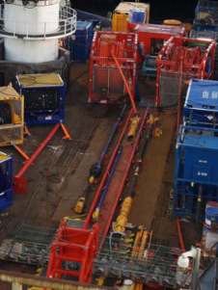
The low-pressure packer tool provides a simplified solution with similar capabilities to SWAT, best suited to mudline well systems.
Product and service line brand, Claxton, has successfully developed and deployed SWAT™, cutting, abandonment and recovery tooling across the world for clients. This includes many category II wells of which all required a shallow cement barrier spanning through the casing annuli.
This experience directly influenced the development of the multi-award-winning suspended well abandonment tool – SWAT. The first tool of its type, SWAT holds the Queen’s Award for Innovation in the UK, and the prestigious Petroleum Institute Platinum Award for Innovation.
Delivered in conjunction with product and service line brand, InterMoor, SWAT opens the opportunity for innovative, cost-saving multi-operator campaigns.
Rated to 5,000 PSI, SWAT is capable of being deployed from any dynamic positioning (DP) vessel, landed on the wellhead and then used to carry out casing perforation, followed by clean-up and placement of the required cement barriers in the well. The wellhead can then be severed using SABRE™, our subsea abrasive cutting tool, and recovered using the wellhead recovery tool, utilising the full subsea decommissioning package.
Using the wiper ball system with SWAT isolates the cement from the wellbore fluid and provides the mechanical barrier to spot cement on, removing the possibility of slumping. This leaves the client with a high-quality, uncontaminated and fully tested cement job.

Link to Vendors website for further information:
SWAT suspended well abandonment tool - Acteon

